BRI’s Chinese transactions in Laos: urban engineering, megastructure and energy.

Table of contents

Acknowledgments 2

Presentation of the project 3

Introduction to the BRI 4

Historical review, from the old silk road to the new one 4

The political outcomes of the BRI 5

The Belt and Road Initiative and its stakes in South-East Asia 6

The global plan in South-East Asia 6

Implications in Laos region 7

Methodology for identifying projects 8

Identified projects 10

Energy 10

Transport 11

Real estate 12

Discussion 14

Conclusion 14

Bibliography 15

# Acknowledgments

I would like to thank Carine Henriot, my supervisor for this project. I enjoyed all our meetings which were moments of reflection but also discussions on other subjects at least as interesting. I would like to thank her a second time for helping me to find my final internship. And one last time for her advice on how to continue my career after my engineering degree.

I did this research work during my Erasmus semester in Ljubljana, Slovenia. This is where I fell in love with the Germans who have been my best friends here! Special thanks to Ann Sophie who was always proud of me when I finished my work just before the deadlines. She was also my lockdown partner when I got COVID and I never laughed as much as I did with her watching The Office. I also think of Johanna and Marie who were my hiking partners and with whom I had long conversations about this work. I don't forget my French colleagues: Valentine, Elisa, Thomas, Hugo, Remy and Pierre-Louis! I guess I'll be in Lyon and Leipzig sooner than they think.

# Presentation of the project

This work is the continuation of a work carried out by Julien Muselet, an engineering student, like me, at the University of Technology of Compiegne. This research was conducted within the framework of the ANR VinoRosa[1] which examines the role of the Chinese government's new Belt and Road Initiative policy on urban development. The report he produced (Muselet, 2021) is based on a quantitative analysis of the China Global Investment Tracker[2] database produced by Derik Scissors of the American Enterprise Institute (AIE). This database includes more than 3700 financial transactions from China in many sectors (energy, transportation, technology, property, etc.). Julien’s work strictly exploited the database to identify actors and trend in Chinese investments, especially in South East Asia (SEA) with a particular attention on some selected countries and urban engineering sectors.

My researches were a qualitative analysis of the Chinese stakeholders investing for the development of Belt and Road Initiative using the same database. My work has narrowed down to Laos and its geopolitical and economic position in the South East Asian region. The main part of my work was to understand the position of Laos and China in the South-East Asia through the prism of the BRI, and then identify the anonymised projects in this database and to produce project sheets describing them. I decided to focus on the three major sectors of Chinese investment in Laos: energy, transport and real estate.

The analysis of these investments and a state of the art on the history of the silk roads and the global and region-specific policy of the Belt and Road Initiative, allowed us to question the role and place of Laos in the development of the BRI. By analysing these different transactions, we try to get an overview of the global transaction between China and Laos. What are the different projects that China is building in Laos and how are they linked? What are the benefits for these two actors? Urbanism wise, how is Laos developing and transforming as a result of these investments?

All my notes and resources are available on my GitHub : <https://github.com/arthur-glg/tz>. This work respects the values of open science and is protected by a Creative Commons BY-NC-SA 4.0 license and I would be honoured to have this work re-used and cited.

# Introduction to the BRI

## Historical review, from the old silk road to the new one

Chinese trade outreach has been known to us for over 2 millennia. The historical Silk Road has been a trade network connecting the east of Asia to the central part of the Eurasian continent. Two hundred years B.C., during its heyday with the Roman and Byzantine governance, and until their fall to the sea routes, these roads connected two geographical extremes (McBride, 2015). These roads gathered together different civilizations as never before. It was not only gold, silk or spices that were traded in the markets along the route, but also knowledge, thought and technology. The power associated with its control and thus its security has shaped an infrastructure commensurate with its importance. The Great Wall of China being the best example[3].

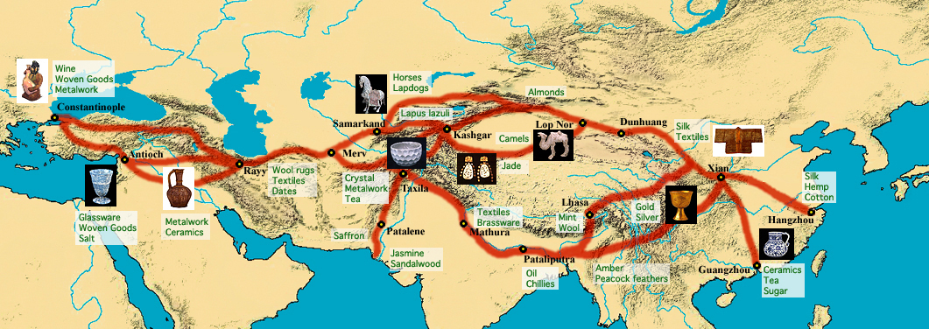

**Figure 1 - Map of silk routes (source: https://95698391.weebly.com/historical-context.html)**

Despite the existence of older routes, we can trace the birth of the Silk Roads to around 130 BC and the sending of an ambassador from the Han dynasty for political and military reasons. It was on his return that he proposed the idea of opening up trade with the regions he had visited, suggesting the economic expansion of the Chinese empire.

On 7 September 2013, the Chinese President delivers a speech at Nazarbayev in Kazakhstan. In what appears to be a response to the 2008 economic crisis (Apostolopoulou, 2021), he sells an economic stimulus that will support the creation of new infrastructure: railways, energy pipelines, highways and streamlined border crossing (McBride, 2015) that will be known as the “Silk Road Economic Belt”. One month after at the Indonesian parliament, the Chinese president also introduced the “Maritime Silk Road”, another infrastructure development around maritime trade along the Asia-Pacific coast, the Indian Ocean to the Mediterranean Sea.

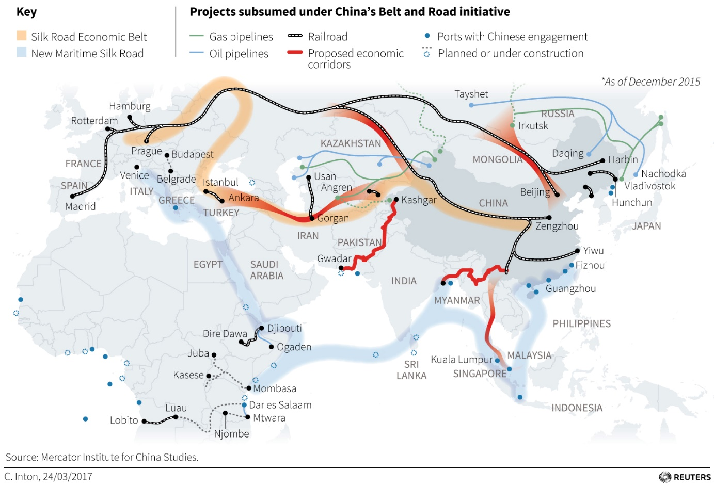

**Figure 2 - Map of the routes developed in the scope of the "Silk Road Economic Belt" and the "Maritime Silk Road"[4]**

It is geographical and political similarities that bring the old and new Silk Roads together. However, the development of these two trade routes is rather different. Where the Silk Road created new urban areas along its route, the Belt and Road Initiative creates new urban areas in order to create this route. In the same way, the Silk Road promoted the creation of multi-cultural cities, whereas the BRI seems to repeat the development of the Chinese model and tends towards a uniformity of spaces (Otmakhova, 2018).

## The political outcomes of the BRI

As the title of Xi Jinping's speech informs us: “Promote people-to-people friendship and create a better future”, the Chinese government emphasises the win-win and collaborative strategy of the New Silk Road. However, this strategy remains unclear and without an official road map, China is free to add new project to the official BRI and remain agile in its decisions and political identity (Narins & Agnew, 2020). In addition, the literature reviewed in this report repeatedly reports the current lack of research depicting a qualitative analysis or retrospective of Chinese actions in building the BRI (Apostolopoulou, 2021), (Urban et al., 2013). This leaves us with a very blurry vision of the past and future evolution of the project.

Despite an often engaged literature and the distance I have taken from it, it is impossible not to consider the China's geopolitical reinforcement on the countries targeted by the BRI. The BRI is, of course, an infrastructure development but while promoting its the economic impact and its support for growth, Beijing is also introducing a form of soft power. Moreover, some regions are instable in terms of geo-politics and security which contrast with the current people-to-people discourse (Sharma & Khatri, 2019). Especially since the BRI will involve sixty-nine countries, that represent 60% of the global population. We can only acknowledge the challenge of bringing together disconnected policies around a common project with the requirement to break down many spatial barriers.

|  |  |  |  |  |  |
| --- | --- | --- | --- | --- | --- |
|  | **Politico-economic** | | | **Physical** | **Socio-cultural** |
| *BRI GOALS* | *Financial integration* | *Unimpeded trade* | *Policy coordination* | *Connectivity* | *People to people bonds* |
| BRI INSTRUMENTS | Capital loans, technical financial tools | Economic cooridors, trading agreement | Diplomatic agreement, policy programmes | Nodal infrastructures, roads, railways, ports, airports, telecommunications networks, pipelines, development zones and cities | Silk road cultural legacy, educational programmes, Chinese culture institutes |
| Special Economic Zones | |

To carry out the development of the project, the Chinese state uses a range of tools. According to (Otmakhova, 2018) we can sort them into three different categories. First of all, the political and economic ones, which make it possible to set up governance in trade. We then speak of investment, political or economic agreement. The so-called "physical" or "socio-economic" tools correspond to the realities on the ground and the results we can observe and will analyse in this report. It is more a question of the Chinese cultural-spatial legitimacy concerning regional trade and the technical know-how for the construction of such large infrastructures.

**Table summarising the goals and tools of the BRI (by Otmakhova)**

The Belt and Road Initiative and its stakes in South-East Asia

The global plan in South-East Asia  
  
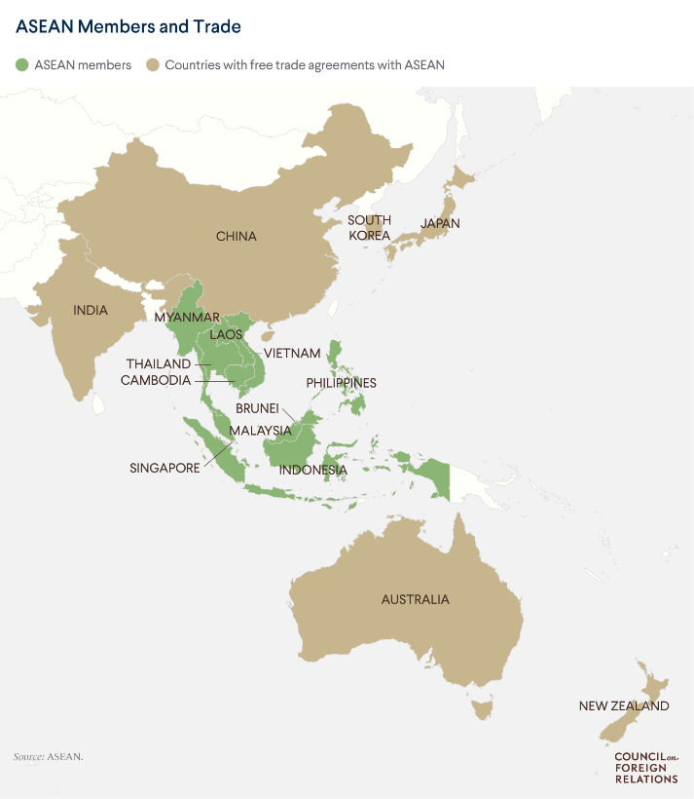The BRI is organising in South East Asia along the China-Indochina Peninsula Economic Corridor (CICPEC). It is the link between the countryside and the sea, a passageway to the southern seas and at the end of its development, it will be a much faster alternative to sea transport (Mottet, 2018). This corridor involves the ten members of the Association of Southeast Asia Nation (ASEAN). Within this group, Laos occupies a central position with the so-called China Laos Economic Corridor. And it is thanks to the development of an express railway, a key project in the development of the BRI, that Laos will connect the Chinese province of Yunnan to the rest of ASEAN.

This economic development project allows countries to enjoy many benefits. Firstly, the BRI helps to reduce the development gap by providing access to better infrastructure. In addition to BRI construction, there are also initiatives related to health and education. The installation of the BRI has also pushed digitisation in some lagging countries. Finally, these economic expansions are pushing countries like Thailand, Indonesia, Vietnam and Laos to have a very strong urbanisation.

**Figure 3 - Map of the ASEAN members and trade allies**

There are joint initiatives between these countries such as the ASEAN Smart Cities Network and the ASEAN Sustainable Strategy. China is obviously the natural partner as one of the leaders in smart city technologies.

This Chinese presence also remains a risk in terms of geopolitics, security and governance and could in the future upset the balance of power in this region of the world, as is already the case with maritime tensions in the South China Sea (Rana & Ji, 2020)**.**

## Implications in Laos region

The country of Laos with which we are currently familiar, the Lao People's Democratic Republic, is relatively new as it was founded in 1975. It is a small country of 7 million people with no sea coast and historically the country has been very little impacted by colonialist policy unlike its neighbours like Vietnam or Thailand. Despite the transition from socialist planned economy to market economy in 1986 with the policies of the New Economic Mechanism, it is since the arrival of the BRI that we have seen an explosion in the number of investments by China in the state of Laos (W. (Kelly) Chen, 2020). We have already mentioned the strategic location of the country within the elaboration of the economic corridor but Laos also represents according to (Lu & Schönweger, 2019) "an archetypal target country for investment" due to its abundance of natural resources, its poor governance of the territory and the fact that it is still an under-developed country.

Economically and politically wise, China arrived in the middle of the rivalry between Thailand and Vietnam over the exploitation of Laos. And this first one, according to (Mottet, 2018), seems to benefit from a capital of sympathy, with the youngest Laotian leaders in particular, and with the urban population in general. However, Laos does not seem to be without ambition and the country remains aware of the importance of its strategic position in the Chinese plans and more globally in the economic development of Southeast Asia. It is also reported that the country allows itself to maintain a certain degree of independence from its powerful neighbours and that China, if it does not succeed in establishing itself in a sustainable manner while avoiding its image as an invader, could see its influence stagnate or even decrease.

A position that China seems to find difficult to follow. Indeed, the first impacts of the BRI are already very visible and the arrival of mega-infrastructures has increased some social and environmental problems. First of all, the mountainous landscape so characteristic of this part of the world is changing and becoming more and more concrete (W. (Kelly) Chen, 2020). As a result, concerns arise regarding environmental preservation: for example, mining and construction in originally protected national parks or hydroelectric constructions altering river ecosystems (Dicarlo, 2017). And from a social point of view, the presence of Chinese infrastructures is becoming more and more noticeable in view of the numerous relocations of populations (Dicarlo, 2020).

# Methodology for identifying projects

The main point of my work is to associate each entry in the China Global Investment Tracker database with a project in Laos with a very high level of confidence. The information at our disposal is the entries in this database. It is these entries that will serve as our identification keys we use the Year, Month, Investor, Quantity in millions, share size, Transaction party, Sector, Subsector, Country and Region entries of the AIE’s database to find online additional information.

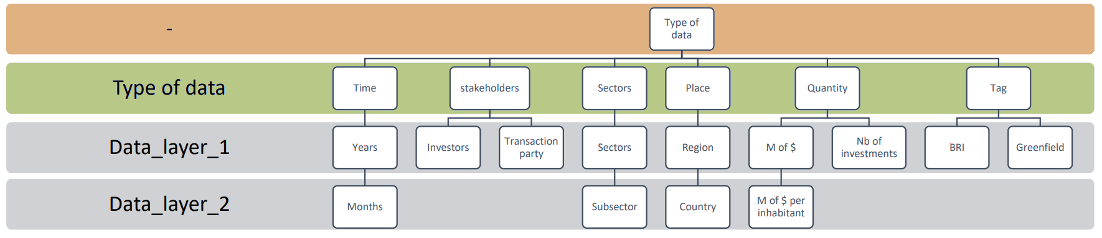

**Figure 4 - UML diagram of the AIE's China Global Investment Tracker database (made by Julien Muselet)**

This way of research is close to what is called OSINT (Open-Source intelligence), we look for information available to all that we come across to come to an understanding of a situation, a chronology and key facts.

The added value of my work is to associate each database entry with:

* a project name: a name that clearly identifies the structure built or under construction. An official or commonly accepted name is expected,
* a location: we must be able to locate the project geographically (a point for a building or an area, a polyline for a road),
* a type: as I find the subsector entry not precise enough, I decided to add an another subcategory,
* a delivery date: we look for the date on which the project was delivered or the planned delivery date.

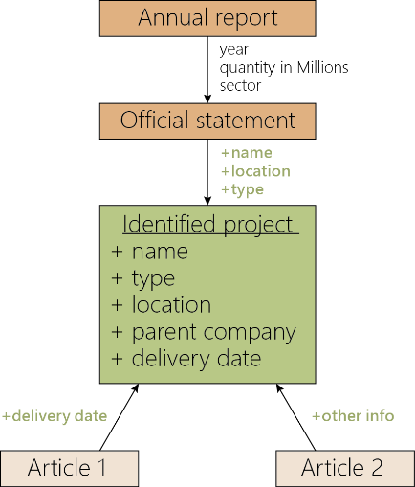While working on the identification of BRI projects, I developed habits, an effective research framework. I have identified two methods of identifying projects:

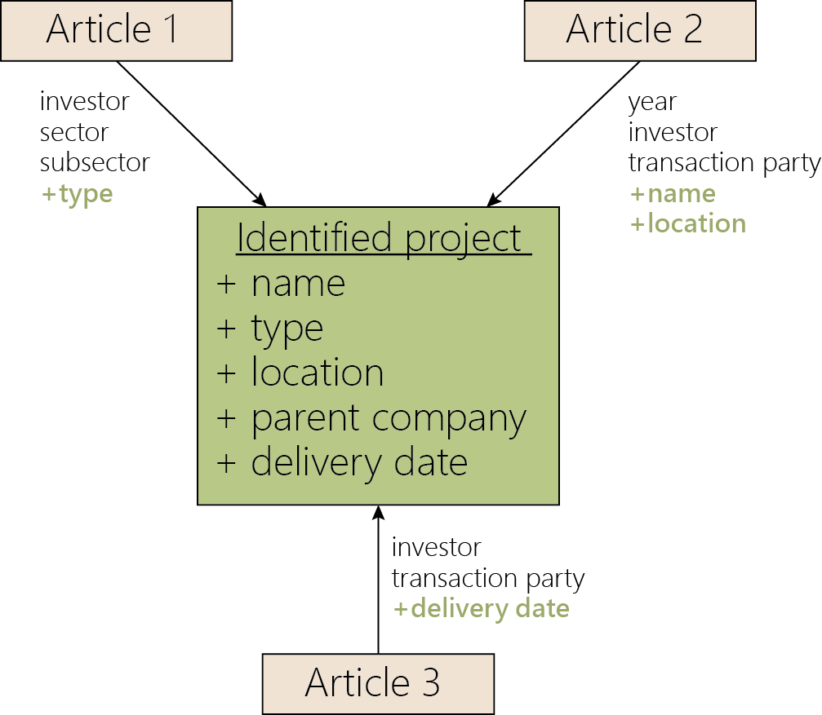

**Figure 5 - Scheme for cross-referencing of press articles methodology**

**Figure 6 - Scheme describing the analysis of official documents and matching press articles methodology**

The first method, the cross-referencing of press article, is to search for press articles that potentially mention the project we are trying to identify. It is by multiplying the searches using different identification keys and by crossing the common points of numerous articles that we manage to put a name on a project in the database with a high level of confidence. The second method uses official documents such as annual reports or press releases of the different companies involved in construction as a starting point. This first step usually identifies the name, type and location of the project. To complete this information, we refer to the strategy of the first method by searching for press articles.

The method was satisfactory, since of the 30 projects to be identified, only six could not be identified, either because of a total lack of information or because of a low level of confidence. In the figure below, the identified entries are shown in green and the unidentified ones in red.

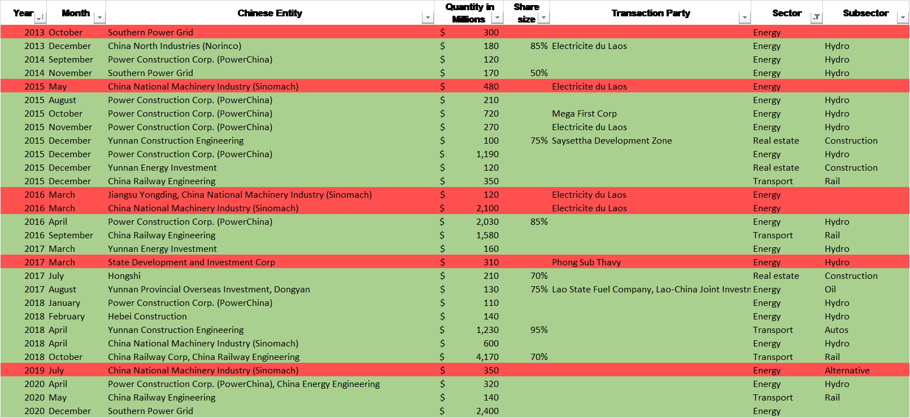

**Table 1 - Summary table of projects identified or not**

# Identified projects

## Energy

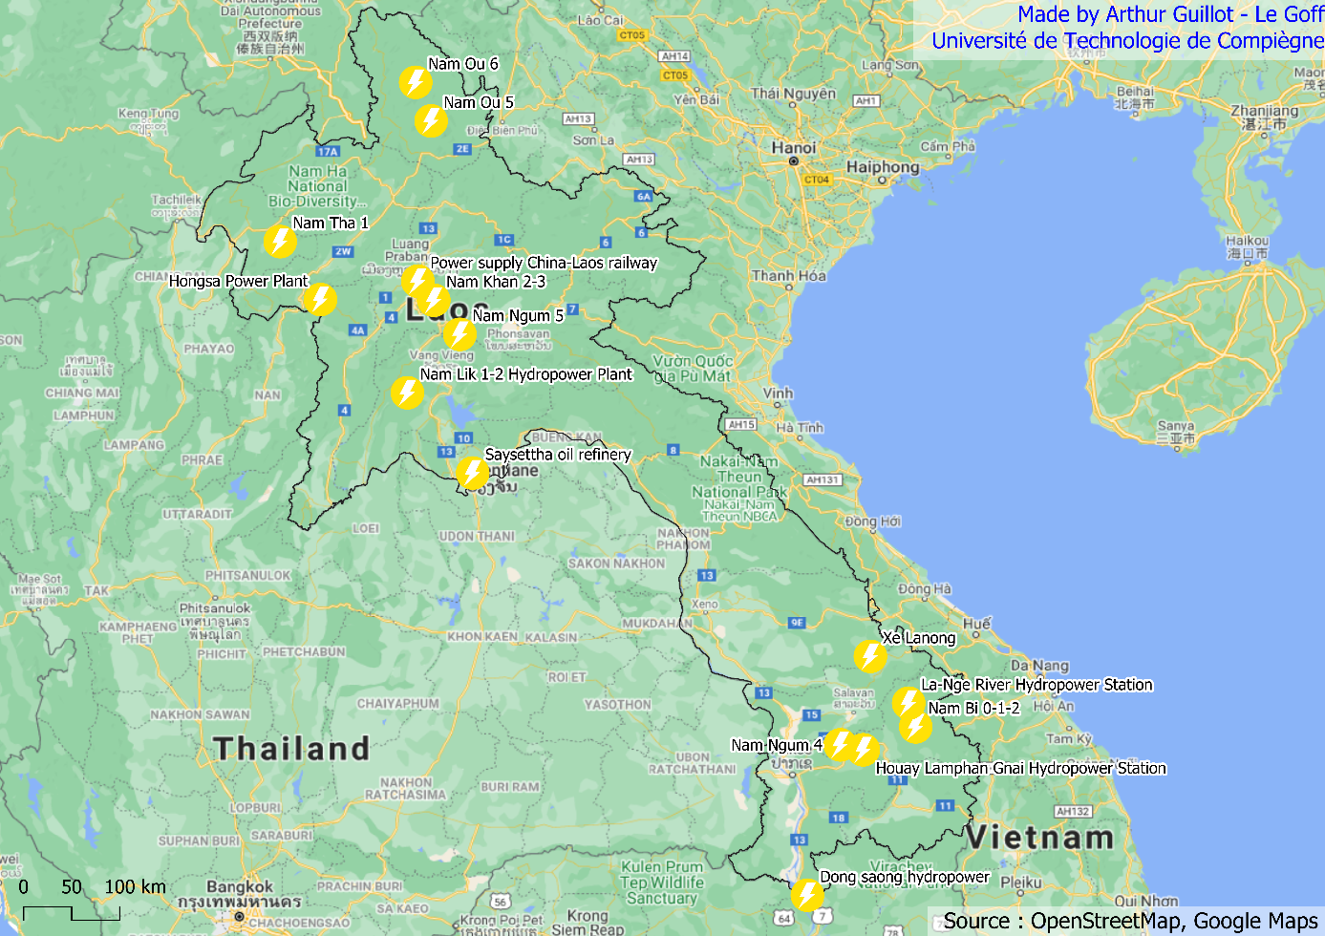

**Figure 7 - Map of BRI projects listed under the energy sector**

The energy sector has the largest number of identifiable and identified projects in the database, 21 and 15 respectively. Laos represents the 5th largest territory in terms of Chinese investment in the energy sector in the Southeast Asian region, despite the country being considered as one of the riskiest. Those investments are motivated by the opportunity they represent and also the possibility for the Chinese state to ensure its energy security in the future (Benazeraf, 2019). These projects related to the New Silk Road policies are mostly hydropower projects. Indeed, the geography of Laos and more specifically the Lower Mekong Basin represents an impressive source of energy. It is also a source of life for the population living on its banks, the river participates in fishing and farming activities, it is also a source of drinking water, a means of transport and a link between the different countries in the region (Urban et al., 2013). China is the largest dam builder in the world and exports its expertise to countries like Laos through its various state owned companies. A double-edged strategy for Laos which recently had to concede shares and a 25-year concession agreement of its company Electricite du Laos to the Chinese.

In addition to political concerns about the energy sovereignty of Laos, there are also concerns about the environment. Furthermore, poorly designed hydropower involves a dilemma. Despite the low CO2 emissions and energy sustainability of the projects, bypassing the regulations related to the basin ecology compensation mechanism can lead to water scarcity, destructive and irreversible changes in water levels and flows impacting both humans and wildlife (Zhong & Hao, 2017).

## Transport

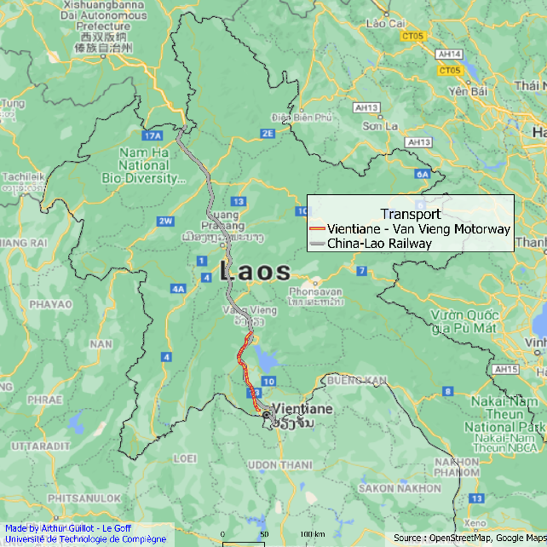The four entries in the database concerning the transport sector correspond to two projects: a railway linking Kunming and Vientiane and a motorway following the same route (for the moment only a portion of this project is operational). These two infrastructures represent the “vital link” of the development of the BRI along the China-Indochina Peninsula Economic Corridor, Laos being the gateway to the other ASEAN countries. The idea for this southern route dates back to 1995 during the ASEAN summit. However, it was a Chinese project, financed by Chinese state money and implementing the Chinese vision, which was inaugurated in December 2021. And my the literature suggests that the railway project involves Laos to a very small extent (Demetriadi, 2020). Already because of Laos's inadequate fiscal capacity, to cover its 30% holding. Laos still had to borrow two thirds of its equity from Chinese banks. More generally, it is a relatively complex financial arrangement which can be described according to the figure below (W. (Kelly) Chen & Dicarlo, n.d.) :

**Figure 8 - Transport projects linked to the BRI in Laos**

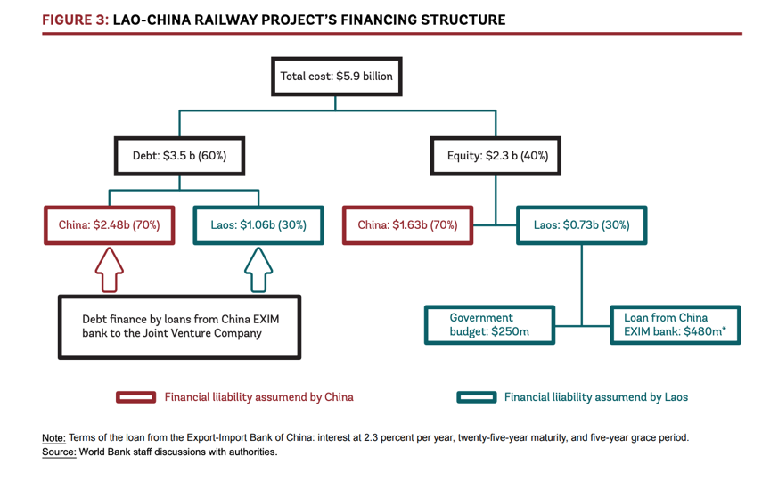

**Figure 9 - Lao-China railway project's financing structure**

Another example of how little Laos is invested in the development of these projects is the near absence of local labour. Based on interviews of sub-contractors, Laos people were only involved in early phases but due to some instability from Laos government into the incoming money, protestation raised and Chinese workers replaced them with a system of wages arriving only every six month to cover those instabilities (W. K. Chen, n.d.).

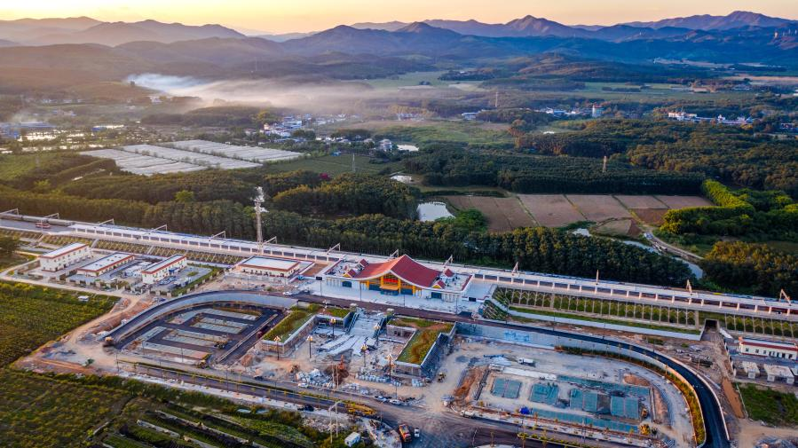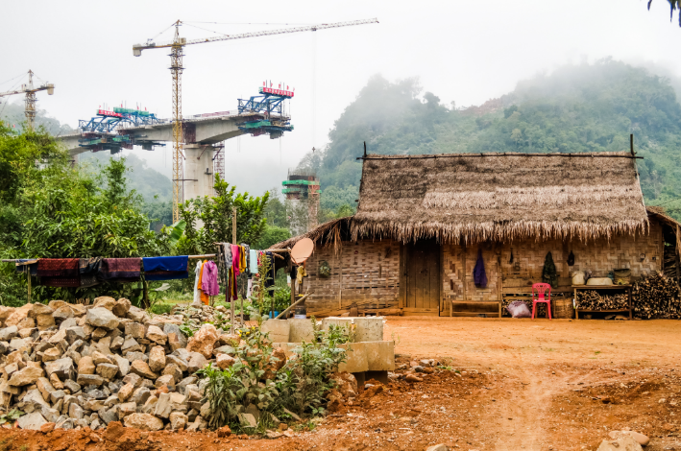But Laos government has also seized the opportunity to develop its domestic connections and enhance trade in its region through its new infrastructure. The numerous train stations will allow the population and goods to move around in safe conditions much more quickly. And the motorway currently being built between Vantiane and Vang Vieng will speed up the journey between the capital and this tourist town (Hart, 2021). However, the image developed by the government is not the one found on the ground and many testimonies reveal that compensation, especially after expropriation, is inadequate or even non-existent due to incorrect qualification of plots. The situation seems unclear and leads to the construction of inequalities, with already poor people finding themselves in situations where the new land they are allocated no longer corresponds to their professional activities (Dicarlo, 2020).

**Figure 10 - Ganlanba station, alongside the China-Lao railway (Xinhua news agency)**

**Figure 11 - Construction of Laos-China Railway pylons and tracks above a village in Oudomxay province, Laos (DiCarlo 2019)**

Therefore, we understand well the transaction which is carried out: The Chinese interest is to use Laos as an interface towards the south of the region, in particular when Vietnam and Thailand block for the moment this logistic development in this way. And we understand as well the interest of Laos to call upon the expertise and the Chinese knowledge, because currently the country would be quite unable to carry out such work.

## Real estate

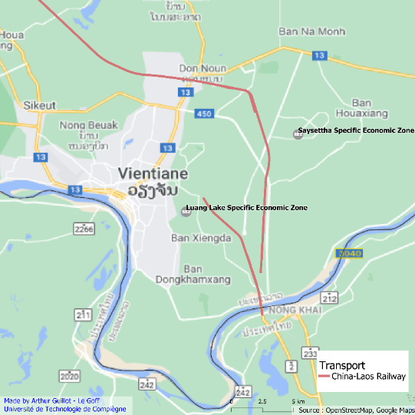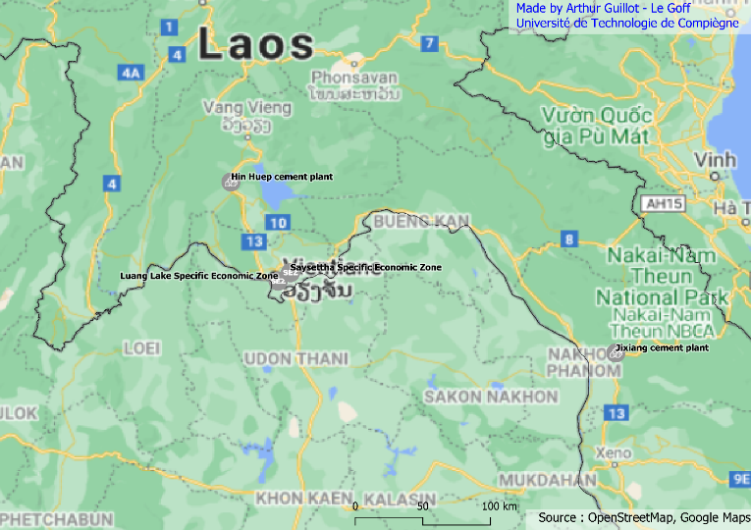For the real estate sector, we were able to identify all the projects in the database. These include four investments that can be grouped into two distinct categories. Two of the projects are Specific Economic Zones (SEZ) attached to Vientiane, while the other two are cement factories far from the capital.

**Figure 12 - Zoom on Vientiane and location of Luang Lake and Saysettha SEZs**

**Figure 13 - Real estate project linked to the BRI in Laos**

The Saysettha and Luang Lake SEZ are globally two new districts regrouping commercial and industrial activities but also residential and touristic areas. These areas are clearly thought of as new, more modern city centres tending towards the principle of smart cities (Apostolopoulou, 2021). The various economic advantages enjoyed by these specific areas (mainly based on the Shenzhen model) allow the national economy to proliferate and attract foreign investment. The development of SEZs started in the early 2000s and are now one of the major national development strategies. Today it represents 352 Lao and foreign companies, a registered capital of nearly 8 billion and 18000 jobs (Li & Wang, 2021).

At present, we are far from the computer generated images that are used for presentations. These SEZs have only just begun to be built and the forecasts (before the COVID period) indicated completion by 2030. Knowing this delivery date is an important point that the quantitative analysis could not identify. Although Julien Muselet's work concluded that the transport sector was the one in which the Chinese state invested the most, it was impossible to take into account the phasing of future investments. And by 2030, the Belt and Road Initiative's investment in the SEZ will be equivalent to that in the railway linking China and Laos.

We have very little information about the different concrete factories. But more specifically, we know that the Jixiang cement factory is a very BRI-like project operating with a BOT business model. We also have confirmation that this project has helped the development of the China-Laos railway. Therefore, we can identify the chronology and logic of Chinese investment. Firstly, the Jixiang cement factory was delivered in 2015, enabling the production of large quantities of raw material for BRI's projects in Laos. Secondly, the development of the railway line and its power supply, a new main axis for trade in Laos, was put into service at the end of 2021. This railway line then connects to the Saysettha SEZ, which will be finished in 2030 but which already features companies such as an oil refinery also listed as a BRI project.

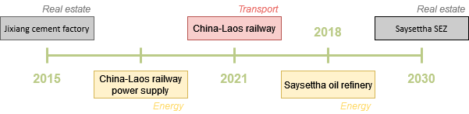

**Figure 14 - An example of a Chinese investment development timeline**

# Discussion

# Conclusion

# Bibliography

Apostolopoulou, E. (2021). A novel geographical research agenda on Silk Road urbanisation. *The Geographical Journal*, geoj.12412. https://doi.org/10.1111/geoj.12412

Benazeraf, D. (2019). *Chinese_Companies_Energy_Activities_in_Emerging_Asia*. 41.

Chen, W. K. (n.d.). *Disabled Localisation: Financial Entanglements and Labour Politics along the Belt and Road in Laos*. 4.

Chen, W. (Kelly). (2020). *The Power of Mirage: State, Capital, and Politics in the Grounding of ‘Belt and Road’ in Laos*. UNIVERSITY OF WISCONSIN – MADISON.

Chen, W. (Kelly), & Dicarlo, J. (n.d.). *Laos–China Railway—The People’s Map of Global China*. 8.

Demetriadi, A. (2020, July 31). *Onboard China’s Belt and Road Express: Does Laos stand to benefit?* [Press]. South East Asia Globe. https://southeastasiaglobe.com/chinas-belt-and-road-initiative-railway-laos/

Dicarlo, J. (2017). *Belt and road infrestructures: Modernist dreams, local dilemmas ?*

Dicarlo, J. (2020). *Mind the Gap: Grounding Development Finance and Safeguards through Land Compensation on the Laos-China Belt and Road Corridor*. https://doi.org/10.13140/RG.2.2.17892.30088

Hart, M. (2021, December 29). *Can China’s Belt and Road Open Up Landlocked Laos?* [Press]. Geopolitical Monitor. https://www.geopoliticalmonitor.com/can-chinas-belt-and-road-open-up-landlocked-laos/

Li, D., & Wang, X. (2021). Land-Use Change and Efficiency in Laos’ Special Economic Zones. *Land*, *10*(10), 1012. https://doi.org/10.3390/land10101012

Lu, J., & Schönweger, O. (2019). Great expectations: Chinese investment in Laos and the myth of empty land. *Territory, Politics, Governance*, *7*(1), 61–78. https://doi.org/10.1080/21622671.2017.1360195

McBride, J. (2015). The New Silk Road—Council on Foreign Relations.pdf. *Council on Foreign Relations*.

Mottet, É. (2018, Aout). Le Laos va-t-il (peut-il) basculer définitivement dans la sphère géopolitique et géoéconomique chinoise ? *Diplomatie N°93*.

Muselet, J. (2021). China Global Investment Tracker. *Université de Technlologie de Compiègne*.

Narins, T. P., & Agnew, J. (2020). Missing from the Map: Chinese Exceptionalism, Sovereignty Regimes and the Belt Road Initiative. *Geopolitics*, *25*(4), 809–837. https://doi.org/10.1080/14650045.2019.1601082

Otmakhova, K. (2018). The Belt & Road Initiative through the Lens of Urbanism. *Delft University of Technology, Department of Urbanism*, 9.

Rana, P. B., & Ji, X. (2020). *China’s Belt and Road Initiative: Impacts on Asia and Policy Agenda*. Springer Singapore. https://doi.org/10.1007/978-981-15-5171-0

Sharma, B. P., & Khatri, R. S. (2019). The Politics of Soft Power: *Belt and Road Initiative (BRI) as Charm Influence in South Asia*. *China and the World*, *02*(01), 1950002. https://doi.org/10.1142/S2591729319500020

Urban, F., Nordensvärd, J., Khatri, D., & Wang, Y. (2013). An analysis of China’s investment in the hydropower sector in the Greater Mekong Sub-Region. *Environment, Development and Sustainability*, *15*(2), 301–324. https://doi.org/10.1007/s10668-012-9415-z

Zhong, C., & Hao, L. (2017). Dilemmas of hydropower development in Laos. *Energy Sources, Part B: Economics, Planning, and Policy*, *12*(6), 570–575. https://doi.org/10.1080/15567249.2016.1244579

1. https://www.irasec.com/page457
2. https://www.aei.org/china-global-investment-tracker/
3. Xinru, Liu (2010). The Silk Road in World History New York: Oxford University Press, p. 11
4. http://www.datajournalism.it/la-mappa-della-nuova-via-della-seta/